AnkiDriod-5091

ID-90

Apk

AnkiDroid-2.9.7.apk

Bug report description

Assume you have a real deck and some filted decks, all filtered are empty now.

RealDeck

FilteredDeckA

FilteredDeckB

FilteredDeckC

FilteredDeckD

Select FilteredDeckA (tap on it), then long tap on FilteredDeckB, select Deck options, do some changes that triggers deck rebuilding. Expectation: FilteredDeckB rebuilt and have cards, actual result: FilteredDeckA rebuilt and have cards.

It's for 2.8.5 beta1, can't check 2.9 right now.

Screen shots sequence

Repeat the following steps until create 4 filtered decks

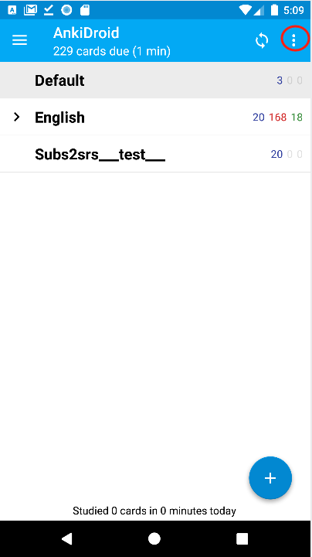

Then,

